K1  
Notes – Quiz 1

Whoo perfect score!

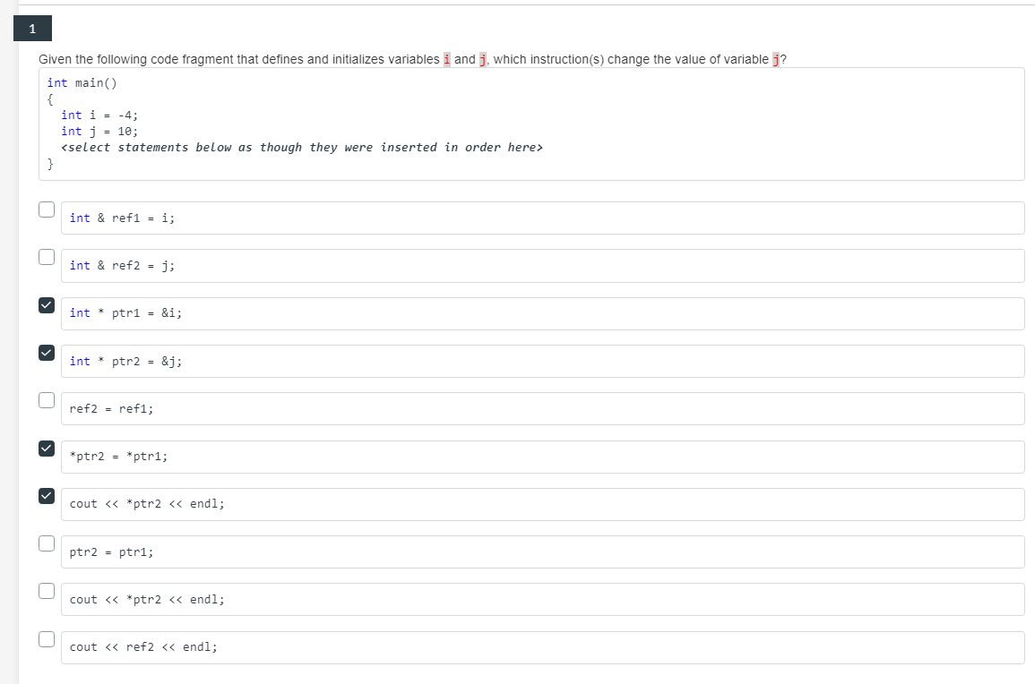

🡨 References

🡨 Overloaded functions



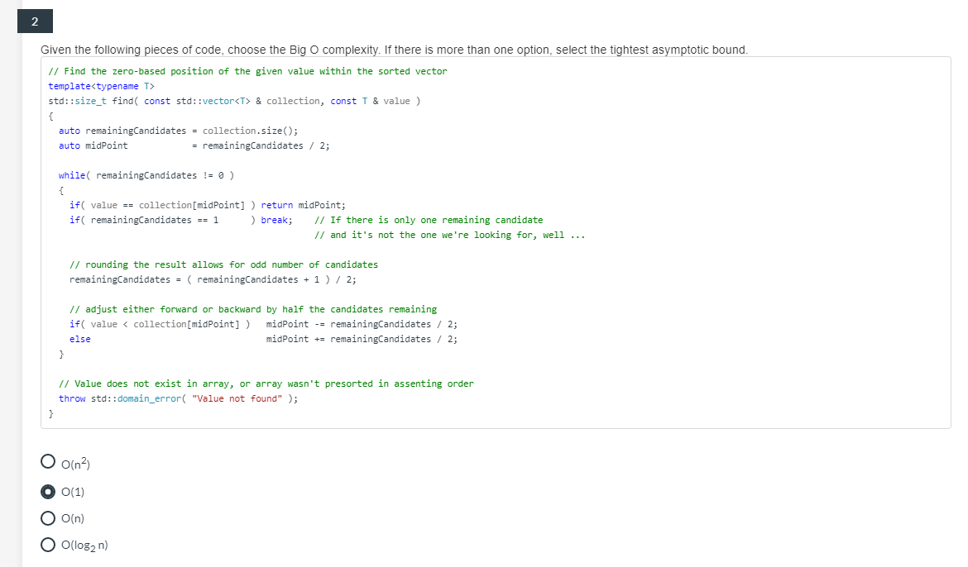



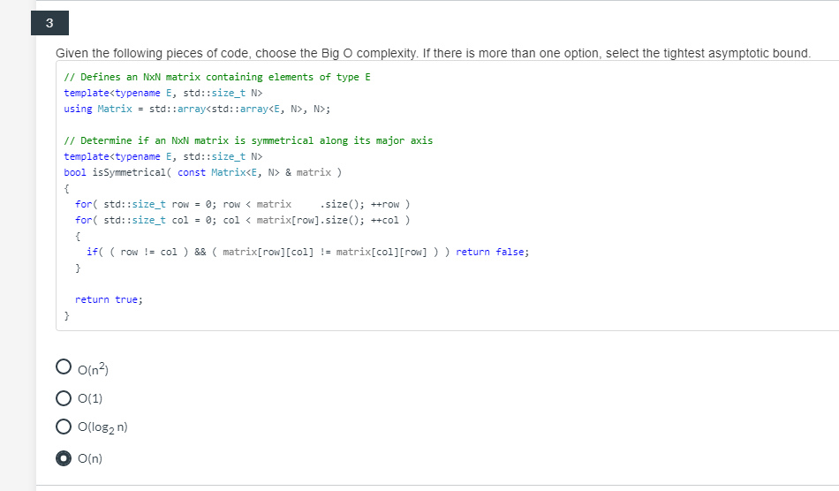



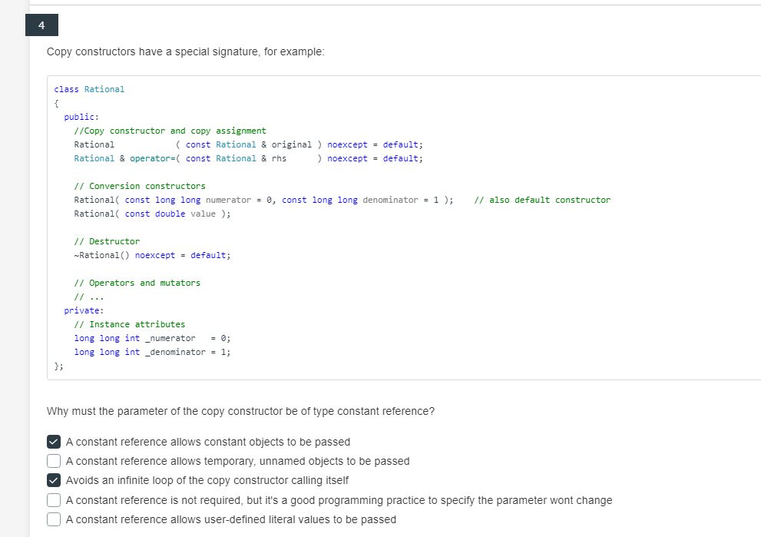



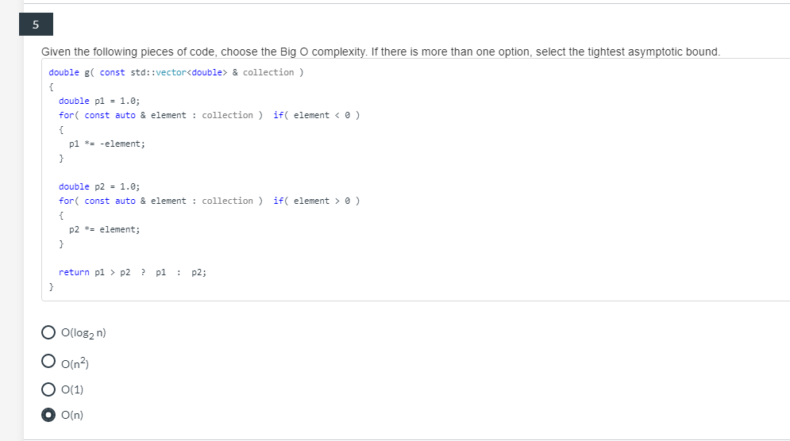



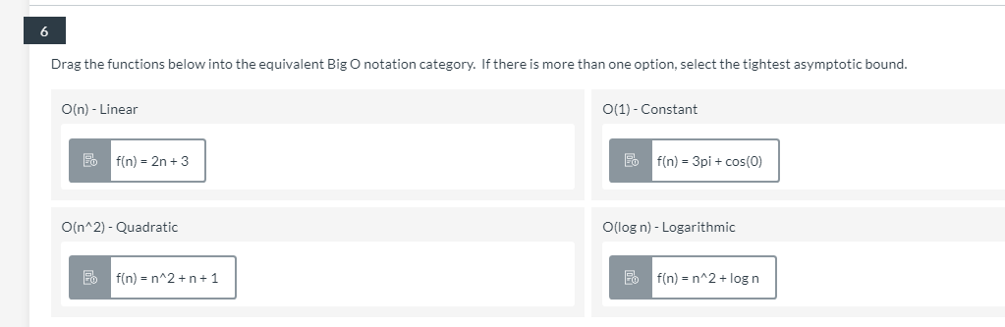



1. f(n) = 2n + 3 : Linear O(n)

2. f(n) = 3pi + cos(0) : Constant O(1)

3. f(n) = n^2 + n + 1 , f(n) = n^2 + log n : O(n^2)

4. no log n

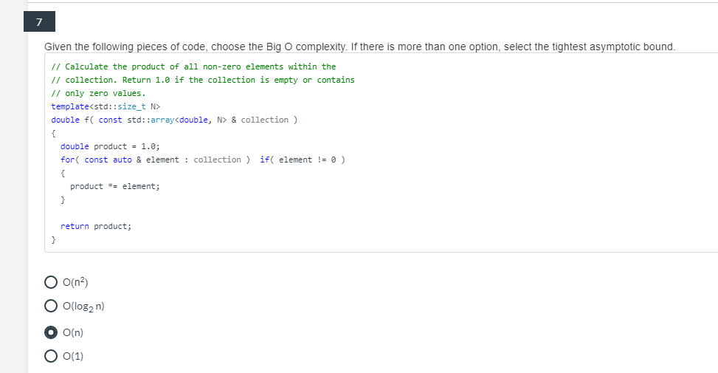



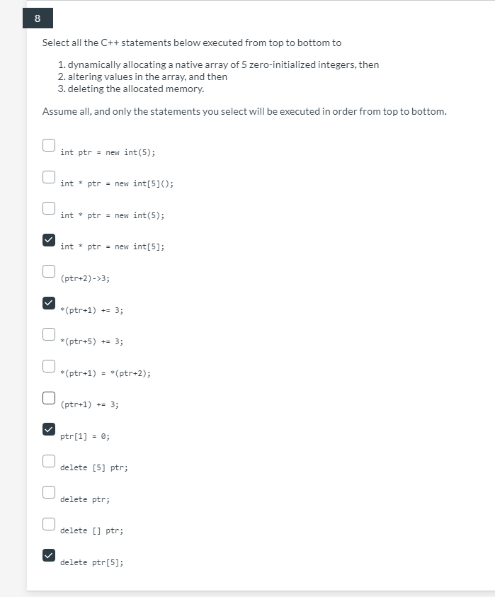



K2

1. Quiz based off of iterators
   1. Question 1 (correct)
      1. Std::array = random-access iterator
      2. Std::vector = random-access iterator
      3. Std::forward_list = forward iterator
      4. Std::list = bidirectional iterator
   2. Question 2
      1. 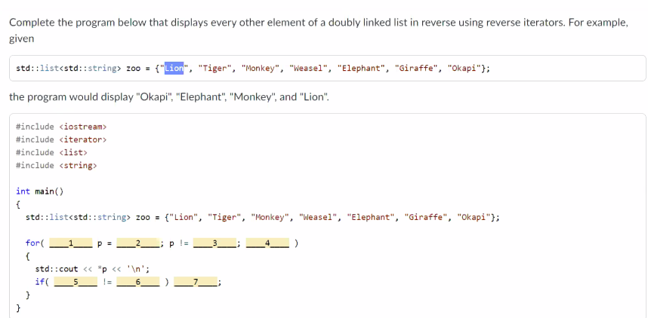
   3. 1. auto 2. Zoo.rbegin() 3. Zoo.rend() 4. ++p  
      5. Std::next(p,2) 6. Zoo.rend() 7. Std::advance(p,2)  
        
        
        
        
        
        
        
        
        
        
      Question 3
      1. 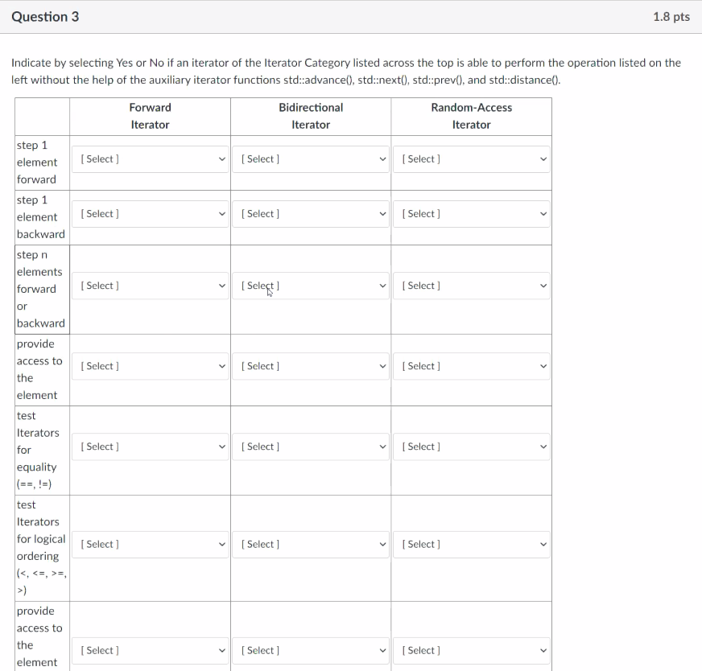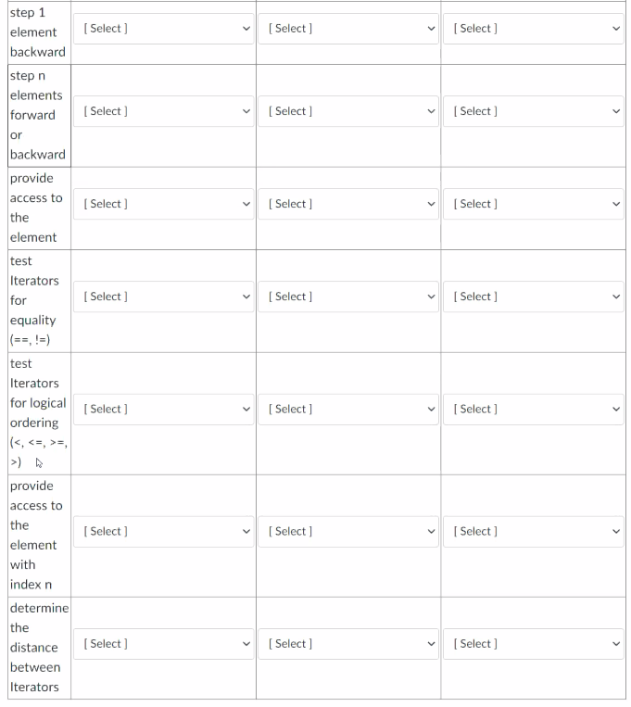­



* 1. Question 4  
     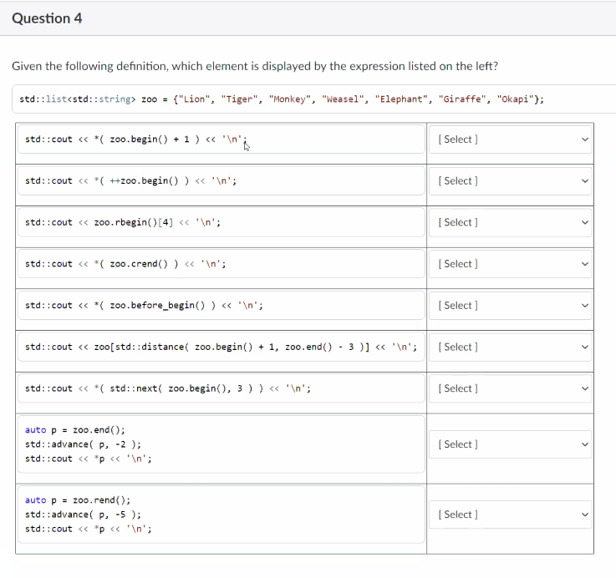
     1. 1.zoo.beg()+1 = **syntax error**
     2. ++zoo.begin() = **Tiger**
     3. Zoo.rbegin().[4] = **syntax error**
     4. Zoo.crend() = **Lion**
     5. Zoo.before_begin() = logic error
     6. Zoo[std::distance..] = syntax error
     7. Std::next(zoo.begin(),3)) = **Weasel**
     8. Auto p = zoo.end(); = **Giraffe**  
        std::advance(p,-2)
     9. Auto p = zoo.rend() = **Elephant**  
        std::advance(p,-5);   
        std::cout<<*p<<’\n’;
  2. Question 5  
     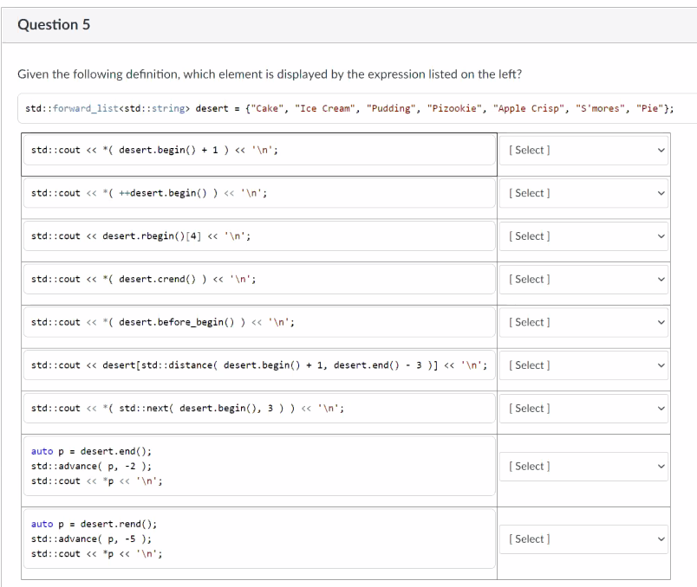
     1. Syntactical Error
     2. Ice Cream
     3. Syntactical Error
     4. Syntactical Error
     5. Syntactical error
     6. Cake
     7. Pizookie
     8. Syntax Error
     9. Syntax Error
  3. Question 6 (correct)  
     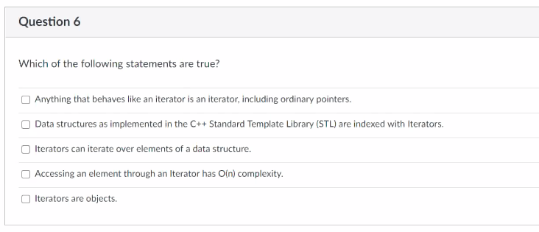
     1. TRUE
     2. FALSE Note to self: iterators are NOT containers so NO it is NOT indexed
     3. TRUE Iterators can itero ver elements of a data structure
     4. FALSE Access an element trough Iterator has O(n)
     5. TRUE Iterators are objects
  4. Question 7 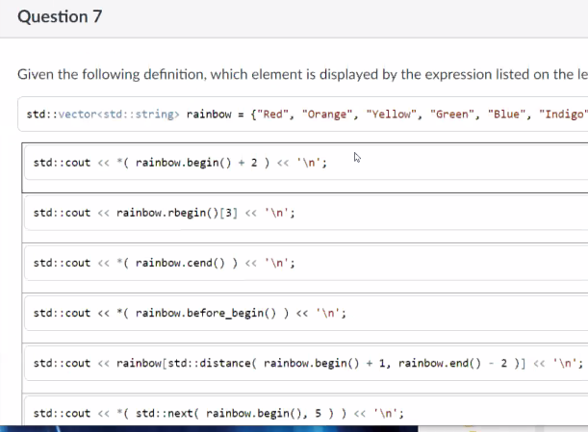
     1. Yellow
     2. Green
     3. Logic error
     4. Syntactical error
     5. Blue
     6. Indigo
     7. Yellow
  5. Logic Error  
       
       
       
       
     K3

1. Question 1  
   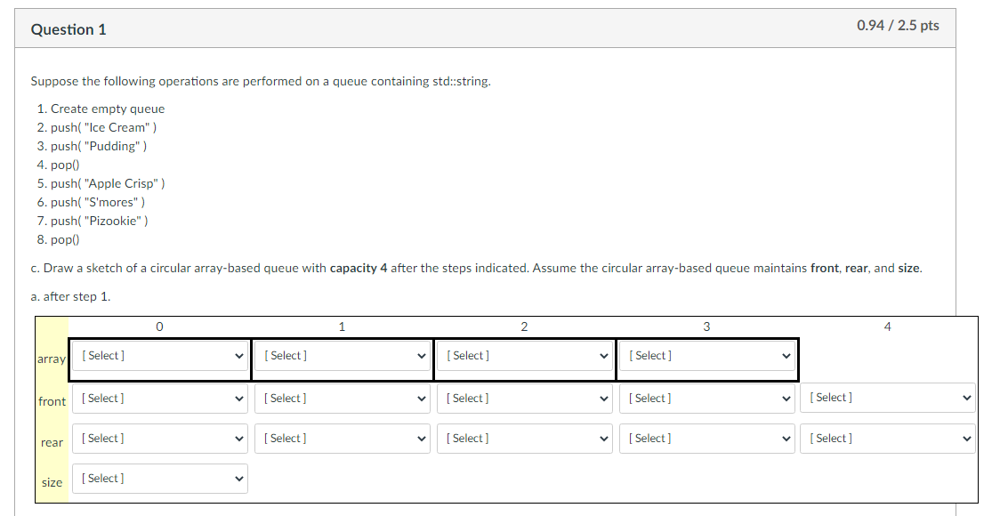  
   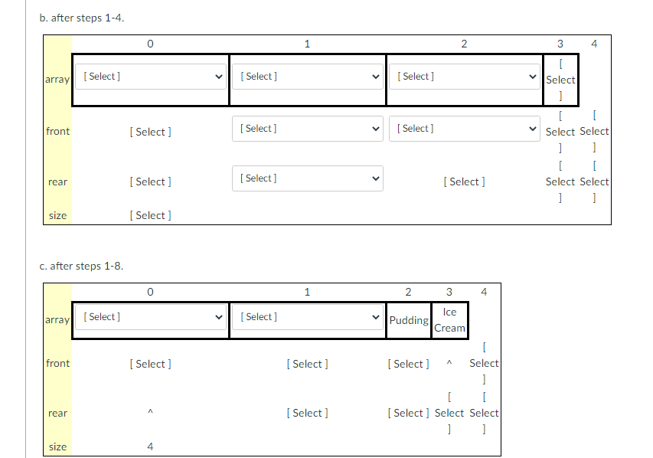
2. Question 2  
   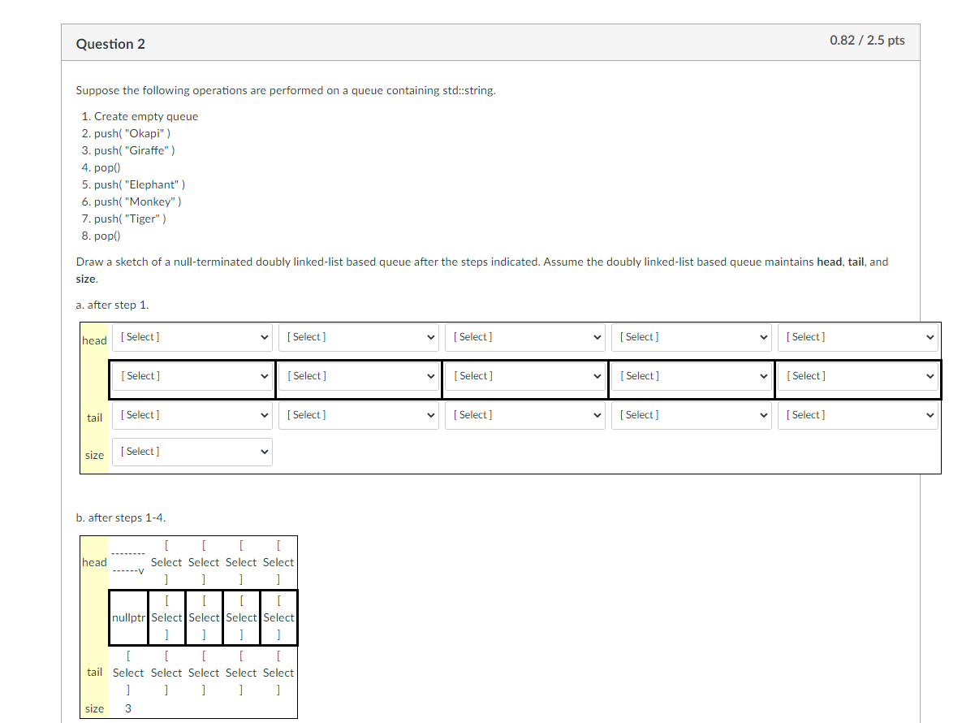  
   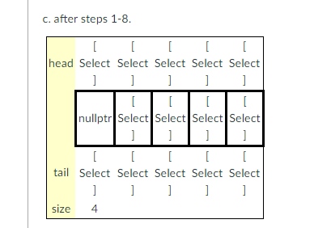
3. Question 3  
   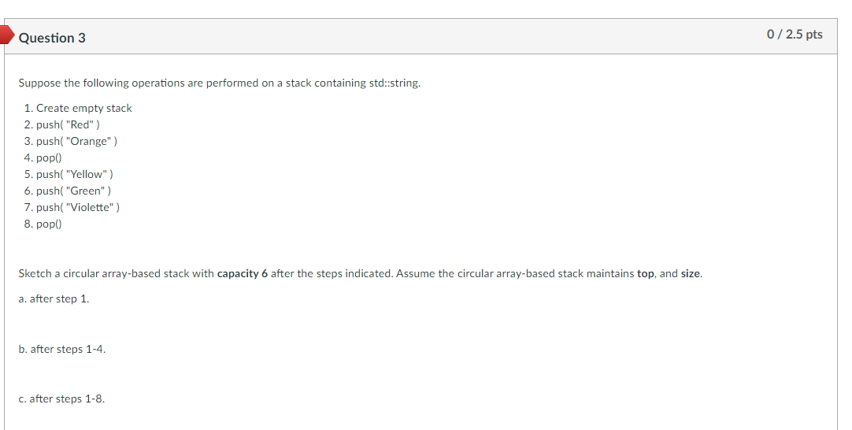
4. Question 4  
   